Madrid, 23rd Saturday November 2019

A CSIC technology enables the access to safe water in rural Ethiopia
- This technology is based on zeolites, an abundant mineral in the Rift Valley that removes fluoride from waters and prevents fluorosis, a bone disease.
- The CSIC has led the project, that has inaugurated two water treatment plants located at 160 kilometres from Addis Ababa.
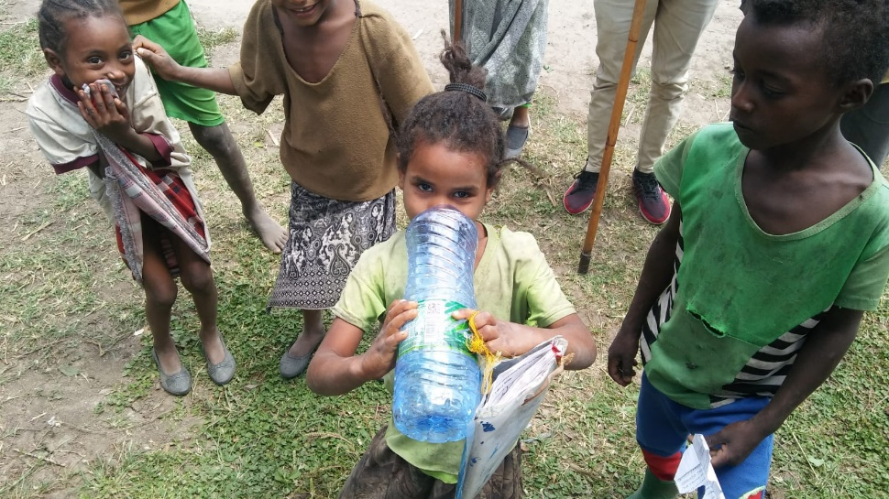
Children are particularly vulnerable to fluorosis because their permanent teeth are still being formed. Photo: Isabel Díaz
In Ethiopia, millions of people are exposed to suffer fluorosis, a bone disease caused by the consumption of fluorinated water. This contaminant of geological origin is present in groundwater. Now, a team of researchers from the Spanish National Research Council (CSIC) and the Addis Ababa University has developed a technology that enables the removal of fluoride from waters in a low-cost and sustainable manner.
This new technology is based on zeolites, an abundant mineral in the Rift Valley that can filter fluoride. The patent that protects the technology has been successfully transferred to the Canarian company Tagua SL., which has launched the manufacturing of the filter based on zeolites on a commercial scale. In addition, the collaboration between the CSIC and the ONG Amigos de Silva has resulted in the development of two water treatment plants with zeolites, which were inaugurated the 23rd November with the presence of a CSIC delegation. They are located in the villages of Dida and Obe, at 25 kilometres from Ziway in the central Rift Valley, and at 160 kilometres from the south of Addis Ababa.
The treatment plants have been inaugurated in two communities of Ziway, where fluorosis has a great impact. Some research show that more than 14 million people in Ethiopia are at risk of suffering dental and skeletal fluorosis. Children are particularly vulnerable to fluorosis because their permanent teeth are still being formed.
The implementation of this technology has resulted from a project led by the CSIC and the ONG Amigos de Silva that has been financially supported by the Spanish Foundation Juan Entrecanales de Azcárate and the Stiftung Freie Gemeinschaftsbank (Switzerland). The aim has been to provide safe water to the rural communities of the Rift Valley by reducing the high levels of fluoride concentration exceeding 1.5 mg per litre (mg/L), which is the limit established by the World Health Organization. In the Ethiopian Rift Valley, 41% of the drinking-water sources have a fluoride concentration exceeding that limit. Food ingredients and food prepared with local water may also be a major source of fluoride consumption.
This project has installed two filters in two contaminated wells in the villages of Dida and Obe that supply water to the local community, that has a primary school for 400 children, a recreational facility and a centre for maternal and infant health with nursing assistance. Water in wells, with a fluoride concentration 2-3 mg/L, will be filtered thanks to this new zeolite-based technology in order to provide the community with safe drinking water.
A low-cost and abundant resource
“Zeolites are a rich natural resource in Ethiopia that has not been exploited due to the lack of scientific knowledge related to its applicability, which could foster its systemic exploitation”, explains Isabel Díaz, CSIC researcher at the Instituto de Catálisis y Petroleoquímica and one of the CSIC patent inventors. Natural zeolites have a volcanic origin and have a microporous structure that can accommodate a wide variety of elements such as sodium, potassium and magnesium.
Zeolites can be applied due to its capacity to the treatment of sewage waters, extraction of ammonia, odour control, heavy metal extraction from nuclear, mining and industrial waste, soil conditioning for agricultural uses and even as an animal feed stock.
The development of this technology is in the line of the CSIC scientific requirements to meet the 17 Sustainable Development Goals of the United Nations, and more specifically the Goal 6: Clean Water and Sanitation.
CSIC Communication

